Azure Search
Platform as a service
Management search
Keyword search
Faceting
Language analyzers
Suggestions/auto-complete
Customizable scoring
Proximity search
Synonyms
Cognitive skills

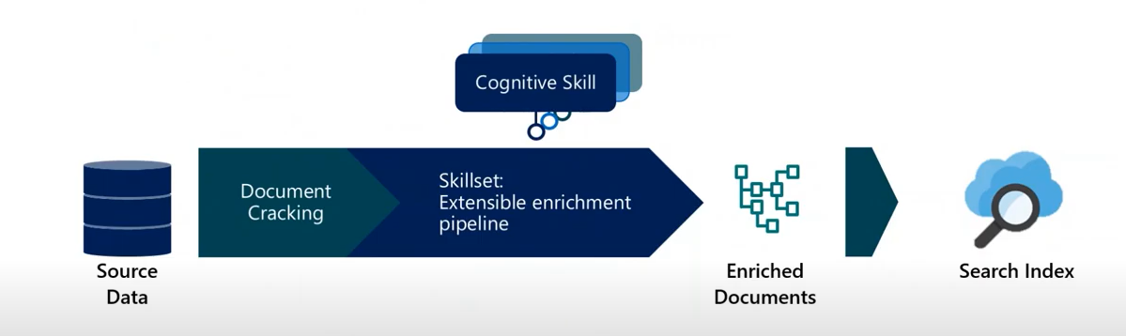

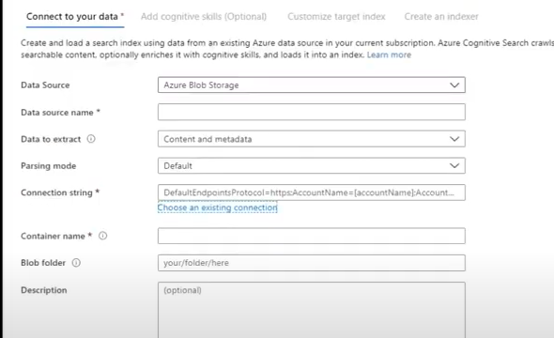

Cognitive service , should be in the same location as the cognitive search

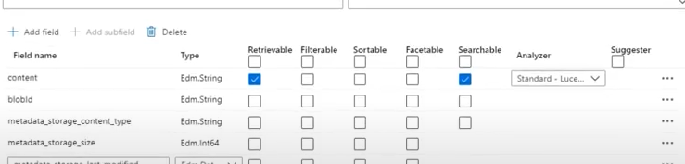

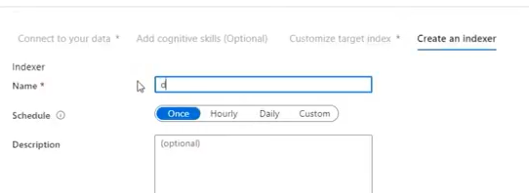
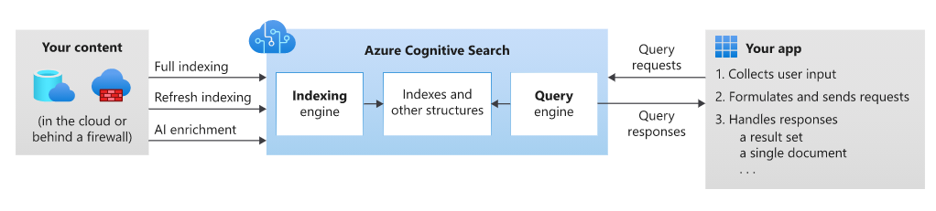
Indexing is an intake process that loads content into to your search service and makes it searchable. Internally, inbound text is processed into tokens and stored in inverted indexes for fast scans. You can upload any text that is in the form of JSON documents.
Additionally, if your content includes mixed files, you have the option of adding AI enrichment through cognitive skills. AI enrichment can extract text embedded in application files, and also infer text and structure from non-text files by analyzing the content.

- Querying can happen once an index is populated with searchable text, when your client app sends query requests to a search service and handles responses. All query execution is over a search index that you create, own, and store in your service. In your client app, the search experience is defined using APIs from Azure Cognitive Search, and can include relevance tuning, autocomplete, synonym matching, fuzzy matching, pattern matching, filter, and sort.

Linguistic analysis
AI enrichment for image and text analysis can be applied to an indexing pipeline to extract text information from raw content. Text from images etc..

Free-form text search, Relevance, Geo-search, Filters and facets

Faceted navigation is enabled through a single query parameter.
Filters can be used to incorporate faceted navigation into your application's UI

Autocomplete,Synonyms , Search Suggestions , Hit Highlighting , Sorting , Paging

Azure.Search.Documents
AzureSearch.SDK.Quickstart.v11

Create two clients: SearchIndexClient creates the index, and SearchClient loads and queries an existing index. Both need the service endpoint and an admin API key for authentication with create/delete rights.

Azure Table Storage

Highly Scalable Very Cheap

Azure Table Storage is a service that stores structured NoSQL data in the cloud , providing a key/attribute store with a schemaless design

It is a sub-service of Azure Storage Account service

Table Storage is less performed when compated to Cosmos DB
Table Storage – storage optimized
Cosmos DB - throughput optimized

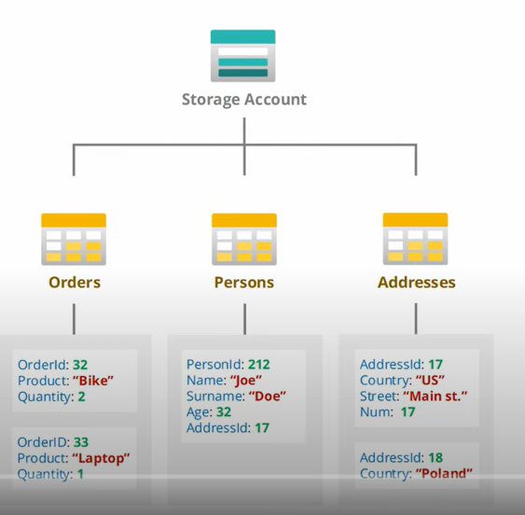

Partition Key , Row Key

New-AzStorageTable
Add-AzTableRow -table -partitionkey -rowKey -property

Get-AzTableRow -tabel -customFilter “(userid eq 1)”

CloudStorageAccount account = CloudStorageAccount.Parse(connectionString);
CloudTableClient tableClient = storageAccount.CreateCloudTableClient(new TableClinentConfiguration());
CloudTable table = tableClient.GetTableReference(tableName);

TabelOperation insertOrMergeOperation = TableOperation.InsertOrMerge(customer);

TableResult result = await table.ExecuteAsync(insertOrMergeOperation);
CustomerEntity insertedCustomer = result.Result as CustomerEntity;

QueryTable

TableOperation operation = TableOperation.Retrieve<CustomerEntity>(firstName,lastName);
TableResult result = await table.ExecuteAsync(retrieveOperation);

https://myaccount.table.core.windows.net/Customers(PartitionKey='MyPartition',RowKey='MyRowKey1')

Azure Batch Jobs

Create a batch account

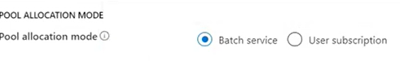
Create a pool Pool ID , Publisher (windows server),sku 2012 datacenter small disk

We have a batch account , and pool
We need to create a bathjob now

Job ID , select a pool under which you want to add

Create a task under a Job

Get started with Azure Batch by running a job from a C# application built on the Azure Batch .NET API. The app uploads several input data files to Azure storage and then creates a pool of Batch compute nodes (virtual machines). Then, it creates a sample job that runs tasks to process each input file on the pool using a basic command.

The app creates a BatchClient object to create and manage pools, jobs, and tasks in the Batch service.

BatchSharedKeyCredentials cred = new BatchSharedKeyCredentials(BatchAccountUrl, BatchAccountName, BatchAccountKey);

using (BatchClient batchClient = BatchClient.Open(cred))

To create a Batch pool, the app uses the BatchClient.PoolOperations.CreatePool method to set the number of nodes, VM size, and a pool configuration.

Here, a VirtualMachineConfiguration object specifies an ImageReference to a Windows Server image published in the Azure Marketplace.

The number of nodes (PoolNodeCount) and VM size (PoolVMSize) are defined constants.

CloudPool pool = batchClient.PoolOperations.CreatePool(
poolId: PoolId,
targetDedicatedComputeNodes: PoolNodeCount,
virtualMachineSize: PoolVMSize,
virtualMachineConfiguration: vmConfiguration);

pool.Commit();

The app uses the BatchClient.JobOperations.CreateJob method to create a job on your pool.

CloudJob job = batchClient.JobOperations.CreateJob();
job.Id = JobId;
job.PoolInformation = new PoolInformation { PoolId = PoolId };

job.Commit();

The app creates a list of CloudTask objects. Each task processes an input ResourceFile object using a CommandLine property.

CloudTask task = new CloudTask(taskId, taskCommandLine);
task.ResourceFiles = new List<ResourceFile> { inputFiles[i] };
tasks.Add(task);

batchClient.JobOperations.AddTask(JobId, tasks);

The app creates a TaskStateMonitor to monitor the tasks to make sure they complete. Then, the app uses the CloudTask.ComputeNodeInformation property to display the stdout.txt file generated by each completed task

Azure Application Gateway

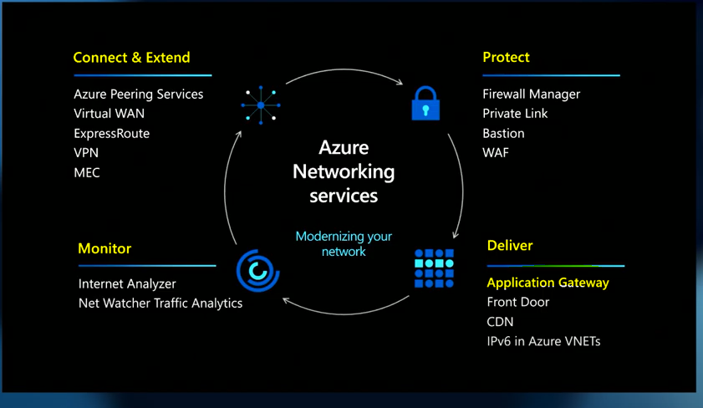

Application Gateway is layer7 regional load balancer
Azure Front Door is layer7 global load balancer

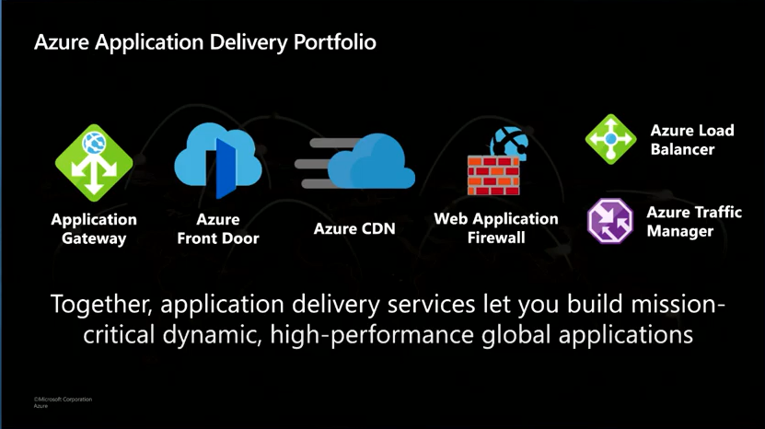

Azure Load Balance , Azure Traffic Manager are layer 4 load balancer.

Application Gateway – Build secure , scalable and highly available web front ends in Azure

Layer 7 load balancing

URL path
Host based
Round robin
Session affinity
Redirection
Header rewrite
URL reqrite
Websocket & HTTP traffic
Connection daraining
Custom error pages

Autoscaling
High performance SSL offloads

It has WAF – Web application firewall capability
Threat intelligence
Site and URL path specific WAF policies
Get filtering on regional WAF

Application Gateway Ingress Controller

Performance benefits over in-cluster ingress controllers
AKS add-on allows for one line deployment of: cluster , Add-on , Application Gateway

Add-on is a fully managed way to integrate native L7 load balancing with AKS

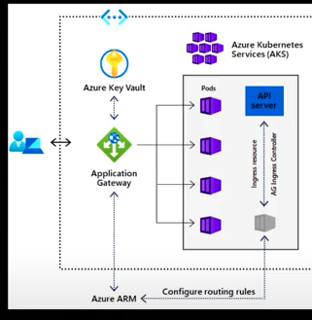

Wildcard Listener
URL Rewrite

It is good to enable WAF at both the edge level – Front door service and regional level

Configure routing rules.

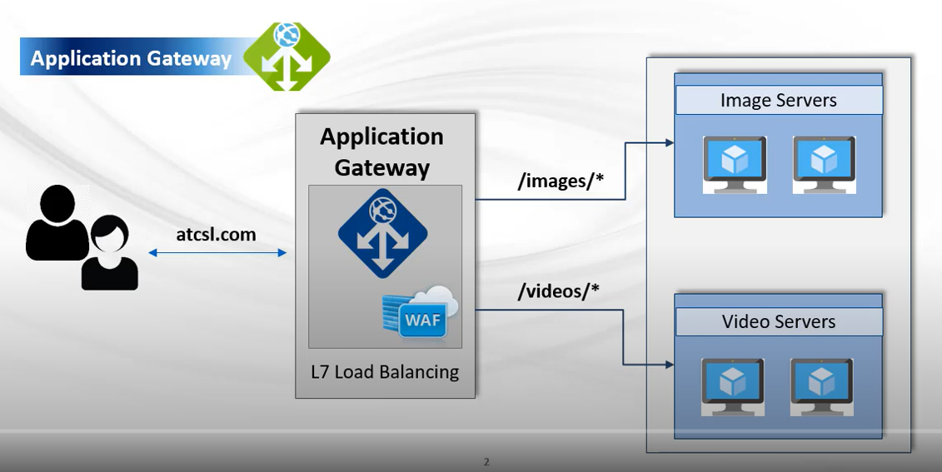

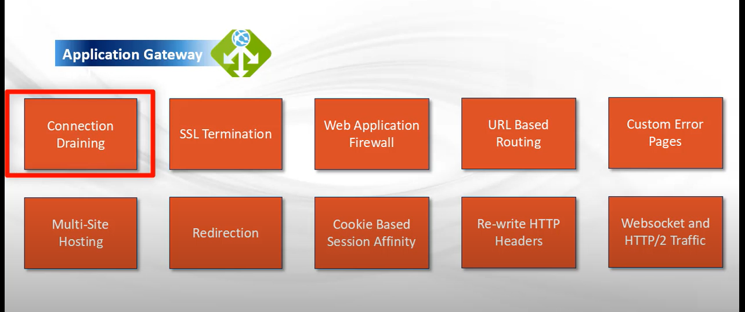

Connection draining – removes backend instances
WAF – centralized protection of common threats
URL Based routing
Custom Error Pages – instead of default error pages
Multi Site Hosting –
Redirection – Automatic http to https , any port to any port
Cookie based session Affinity – all subsequent traffic to same server for processing
Re-write HTTP Headers -
Websocket and HTTP/2 Traffic

Webhook Event delivery
If you're using any other type of endpoint, such as an HTTP trigger based Azure function, your endpoint code needs to participate in a validation handshake with Event Grid. Event Grid supports two ways of validating the subscription.
Synchronous handshake : The data portion of this event includes a validationCode property.
Asynchronous handshake : In certain cases, you can't return the ValidationCode in response synchronously
Microsoft.EventGrid.SubscriptionValidationEvent.

[
{
"id": "2d1781af-3a4c-4d7c-bd0c-e34b19da4e66",
"topic": "/subscriptions/xxxxxxxx-xxxx-xxxx-xxxx-xxxxxxxxxxxx",
"subject": "",
"data": {
"validationCode": "512d38b6-c7b8-40c8-89fe-f46f9e9622b6",
"validationUrl": "https://rp-eastus2.eventgrid.azure.net:553/eventsubscriptions/myeventsub/validate?id=0000000000-0000-0000-0000-00000000000000&t=2021-09-01T20:30:54.4538837Z&apiVersion=2018-05-01-preview&token=1A1A1A1A"
},
"eventType": "Microsoft.EventGrid.SubscriptionValidationEvent",
"eventTime": "2021-00-01T22:12:19.4556811Z",
"metadataVersion": "1",
"dataVersion": "1"
}
]

API Management Policies
Inbound , Backend , Outbound , OnError
Policies are applied at : global level or product level

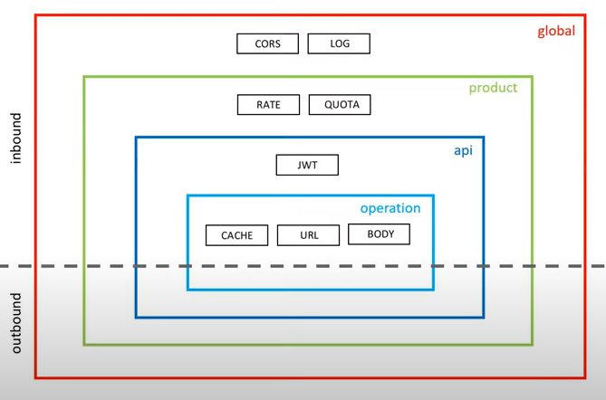

Access restriction policies , Advanced policies , Authentication policies , Caching policies , Cross domain policies , Transformation policies , Dapr integration policies , Validation policies

Application Insights

TelemetryClient telemetry = new Telemetry();

var dictionary = new Dictionary<string,string>();
dictionary.Add(“term”,searchterm)
telemetry.TrackEvent(“Searched”,dictionary) – event is “Searched”

or
telemetry.TrackEvent(“FilteredOnStatus”,dictionary);

On the client side
window.appInsights.tractEvent(“ServiceClick”,dictionary)

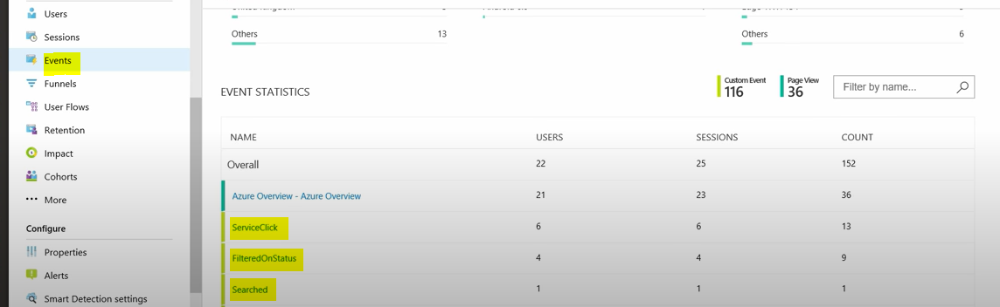

Manually configure the application insights

Startup.cs
services.AddApplicationInsightsTelemetry();

Appsettings

“ApplicationInsights” : {
“InstrumentationKey” : “myKey” //this you get from Azure Portal
}

Logging : { LogLevel : {“Default” : “Information”}}

(ILogger<WeatherForecastController> logger)

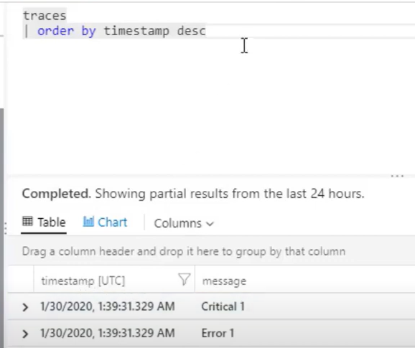

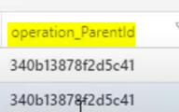

operation_ParentId – same http request

Container registry
$ az acr build -t azfriday/greetme -r azfriday -f GreetMe/Dockerfile .
$ az acr credential show -n azfriday –query “passwords[0].value” -o tsv
$ az container create -n azfriday -g az-Friday-sql –image azfriday.azurecr.io/azfriday
$ az container exec –resource-group az-friday-sql –name azfriday –exec-command “dotnet run”

Diagnostic Logging

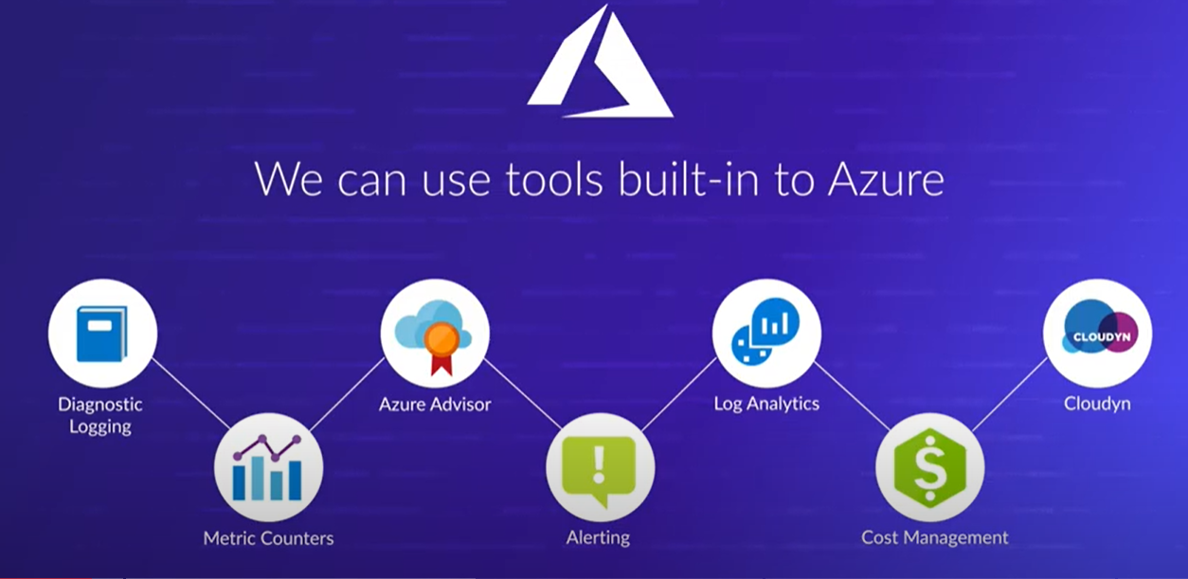

3 types of Logs
Activity Logs
Diagnostic Logs
Application Logs

Activity logs provide a record of operation from a subscription level executed against the resource
Diagnostic logs are collected within a subscription at the Azure Resource level
Application logs are logs generated by applications or services within a guest OS

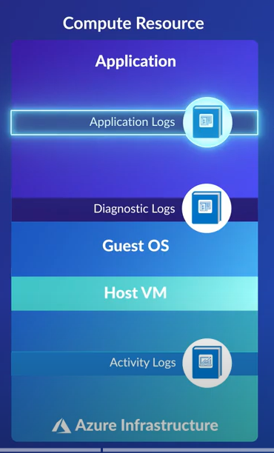

API Management
Front end API - Azure API management will give you
Back end API - API which are the actual API’s
Product - Group of API’s

API Management – we can add Blank API , OpenAPI , WADL , Logic App , App Service , Function App

Azure Container Registry
Azure Container Registry is a private registry service for building, storing, and managing container images and related artifacts.
Create an ACR instance using the az acr create command. The registry name must be unique within Azure, and contain 5-50 alphanumeric characters
az acr create --resource-group myResourceGroup \
--name myContainerRegistry007 --sku Basic
To login to container
az acr login --name <registry-name>

docker pull mcr.microsoft.com/hello-world
docker tag mcr.microsoft.com/hello-world <login-server>/hello-world:v1
docker tag mcr.microsoft.com/hello-world mycontainerregistry.azurecr.io/hello-world:v1
The following example lists the repositories in your registry
az acr repository list --name <registry-name> --output table
to show tags
az acr repository show-tags
deploying using ARM
az deployment group create \
--resource-group $Resource_Group_Name \
--template-uri https://raw.gitbubusercontent.com/
--parameters siteName=$SITE_NAME

Enable the Event Grid resource provider

az provider register --namespace Microsoft.EventGrid
az eventgrid event-subscription create\
--name event-sub-acr \
--source-resource-id $ACR_REGISTRY_ID \
--endpoint $APP_ENDPOINT

Container build

az acr build --registry $ACR_NAME --image myimage:v1 -f Dockerfile https://github.com/Azure-Samples/acr-build-helloworld-node.git#main

eventviewer.azurewebsites.net

Delete an image
az acr repository delete –name $ACR_NAME --image myimage:v1

Basic : 10GB , Standard : 100GB , Premium : 500GB
Geo-replication and Availability zones are available in premium

Steps to create container images
- Cloned the application source from Github
- Create a container image from the application source
- Tested the container locally
Liveliness probes and readiness probes in container

Push an image to the container
az acr login
docker login myregistry.azurecr.io
docker pull mcr.microsoft.com/oss/nginx/nginx:1.15.5-alpine
docker run -it –rm -p 8080:80
docker tag
docker push myregistry.azurecr.io/samples/nginx

docker rmi myregistry.azurecr.io/samples/nginx – remove the image

az acr repository delete --name myregistry –image samples/nginx:latest

Container registry – stores the images
Container instances – runs the images

Azure Diagnostics Logs - App Service
App Service provides a dedicated, interactive diagnostics tool to help you troubleshoot your application. For more information, see Azure App Service diagnostics overview.
Select On for either Application Logging (Filesystem) or Application Logging (Blob), or both.
To enable web server logging for Windows apps in the Azure portal, navigate to your app and select App Service logs.
To stream logs use below command
az webapp log tail --name appname --resource-group myResourceGroup
Diagnose and solve problems Web App Down , Web App Slow , High CPU Analysis , Memory Anaysis , Web App Restarted
Application insights
Download logs from Kudo console
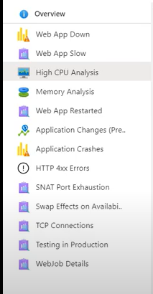
Cosmos DB
Azure Cosmos DB is a fully managed NoSQL database for modern app development. Single-digit millisecond response times, and automatic and instant scalability, guarantee speed at any scale.
- Real-time access with fast read and write latencies globally, and throughput and consistency all backed by SLAs
- Multi-region writes and data distribution to any Azure region with the click of a button.

Choose from multiple database APIs including the native Core (SQL) API, API for MongoDB, Cassandra API, Gremlin API, and Table API.

Build apps on Core (SQL) API using the languages of your choice with SDKs for .NET, Java, Node.js and Python

Miscellaneous
Adding app insights into the function
Add – config – APPINSIGHTS_INSTRUMENTATIONKEY

We can see live metrics in Application Insights

To add logs , add dependency injection for TelemetryClient telemetry

Telemetry.TrackTrace
Telemetry.TrackPaveView(new PageViewTelemetry {})

EventGrid

Filters - Subject Filters , Advanced filters
Storage Account – Create subscriptions in the resource
Dead lettering - Save events that cannot be delivered to storage
Events will be dead-lettered after either the number of delivery attempts is exceeded or the time to live has elapsed
(1-1440 minutes)
We can also set a time at which the event subscription will automatically be deleted
Free Usage – 100,000 Operations

